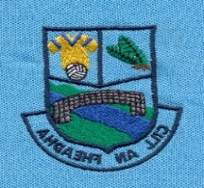
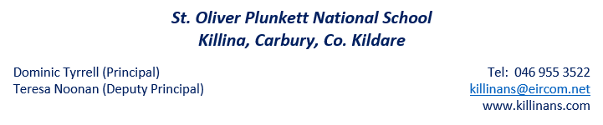
Plunkett’s Post

Upcoming Dates for the Diary
Confirmation: Wednesday 27th February.
Book Fair: Wednesday 6th March.
World Book Day: Thursday 7th March.
1st Confession: Wednesday 13th March.
St. Patrick’s Day: School closed Monday 18th March & Tuesday 19th March.
Easter Holidays: School closed Monday 15th April to 26th April. Friday 12th April is last day of term.
Attendance & Punctuality
As everyone is aware, our official school start time is 9.20am. Children can arrive in school at 9.10am. We are now required to record punctuality in our school attendance system, so we ask that all children are in school by 9.20am.
Pilot Programme for Speech, Language & Occupational Therapy
Our pilot project is in full swing and our boys and girls (up to second class) are getting lots of support with speech, language and occupational therapy. We are very lucky to be involved in this scheme. Teachers and therapists will contact parents if they feel that any student needs further support in any of these areas.

Non Uniform Day (‘Lá Glas’)
Our Student Council have been very busy thinking of ways that they can improve our school. They have decided on getting nets for our goals and buying some new goals for the younger classes for our pitch. They have shown great leadership in discussing the needs of our students, sourcing and pricing nets/goals and thinking of ways that they can raise money to buy them. They have decided to run a ‘Lá Glas’ (Green Day) on Friday 15th March. Each child can bring in €2 and we will use this money to buy nets/goals. We will hopefully have them ready to go by the time we are back on the field.
School Self Evaluation
Our school has been busy working on evaluating our approach to the teaching of Irish. We will publish our findings on the school website. The boys and girls are busy learning new games ‘as Gaeilge’ and developing their use of the Irish language in fun and informal ways. We will have an Irish corner on our Newsletter (and on the website) which will share tips and tricks with parents for using Irish at home.
Aldi Sticker Collection
Many thanks to all our families who have assisted us in collecting stickers for our Aldi poster. We have already filled two posters and will be receiving some rugby balls and other sports equipment as a result. Each poster that we fill gives us one entry into a draw for a chance to win €50,000 for sports facilities for our school.
Acceptable Use Policy
With the recent investments we’ve made into developing our IT equipment, it prompted us to update our ‘Acceptable Use Policy’ (AUP). This policy outlines the rules/protocols that will help to protect our children when they use the Internet. This policy will be sent home to all families this week. All families must return the signed permission form to the school indicating that you agree to follow ‘Our Acceptable Use’ of the internet procedures.
Clothes Collection
A Clothes Collection will take place on Wednesday 6th March. This is an opportunity to clear out your wardrobes and presses for old /unwanted clothing, shoes, belts, handbags, towels, curtains and bedlinen. Please note we cannot accept underwear, pillows or duvets. We thank you for your support in the past and hope you can remind your friends/family and neighbour’s to support this upcoming collection. Money raised from the Clothes Collection helps fund equipment for our school. We are also helping the environment by recycling all these unwanted items.
Parents Association
Many thanks to our wonderful Parents Association for their recent bag pack that they organized in Dunnes Stores. It was a fantastic success and we really appreciate the support of our Parents Association. We hope to use the funds raised to further develop our IT equipment and to get a new sign for the front of our school.
Book Fair
The Celtic Travelling Book Fair is coming to our school on Wednesday 6th March. The Book Fair is bringing a great selection of books to inspire and entertain young readers. Your child will be given a book token this week for €1.50 which can be used off the purchase of a book at the Book Fair or it can be redeemed in bookshops supporting World Book Day. We will be celebrating World Book Day on Thursday 7th March. On that day we would like the children to dress up a their favourite book character. Parents are welcome to come to the Book Fair on Thursday 7th March from 1.30 – 3pm. The children will have opportunities to purchase books on Thursday, Friday, Monday and Tuesday.
Active Flag
The children from Junior Infants to 4th class are taking part in the “Climb the Height” skipping challenge. This initiative encourages the children to be active and to work together to climb the highest peaks in Europe. We are looking forward to seeing how many mountains our school can climb!
Confirmation
We want to wish our sixth class boys and girls all the best for their Confirmation Day, this Wednesday. We hope that you will all have a wonderful day.
Engineers Week
Saturday 2nd March – Friday 8th March 2019
We will be celebrating Engineers Week. All classes will participate in organised activities. The children will showcase their investigations and experiments on Friday 8th March. All parents from 1st – 6th classes are welcome to view the showcase from 2pm – 3pm. Parents from Jnr & Snr Infants are invited in at 1.30pm. We look forward to a great week of promoting and enhancing our budding engineers in Killina N.S.

