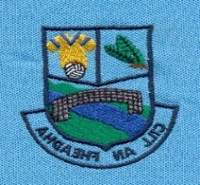
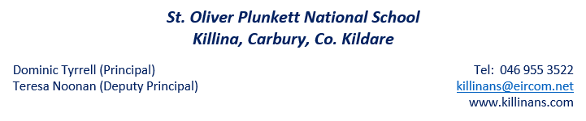
Plunkett’s Post

Monday, January 13th 2020

Welcome back to everyone! We want to wish a very Happy New Year to all of our families. We wish each member of our school community the best of health and happiness for 2020. We hope that you had an enjoyable Christmas break and that you enjoyed lots of family time. We are delighted to see the boys and girls back for our new term and we look forward to the many exciting things that we have planned for this term. This newsletter gives a brief overview of some events and activities that the school has to look forward to.
Peace Proms
Our 3rd to 6th class children are busy preparing for the Peace Proms concert. It will be taking place on February 1st in the RDS. We are very excited to be taking part in this huge event and we look forward to showcasing the children’s hard work whilst on stage. There are still some tickets available if parents wish to purchase them. Please visit www.peaceproms.com. We will send out more information on this closer to the time.

Winter bugs and flu symptoms
A reminder that if your child is unwell, please keep them at home until they are feeling better. We want to minimise the transfer of germs/bugs within our classrooms. For more information on keeping well this season, please check out www.undertheweather.ie.
Active Schools
Daily Mile
We are looking forward to starting Our Daily Mile initiative this week. Please remember to send runners in with your child every day or leave an old pair of runners in school.
Swimming (1st/2nd)
1st and 2nd class will be commencing their six-week block of swimming lessons in Edenderry pool.
Dance
We are focussing on the ‘Dance’ strand in PE this month and next. Ask your children to teach you a few moves of whatever dance they are learning in school.
Bag Pack Volunteers
Our school has been given a weekend for Bag-packing in Dunnes Stores. The bag pack will take place on Friday 24th and Saturday 25th January. This was a huge success last year and we hope to repeat that this time round. We really need your support and hope that you will give the school some hours of your time to support this very worthwhile fundraiser. Please return the form that was sent home last week or write a note into your child’s homework diary.

Voluntary Contributions
Many thanks to our families who have generously submitted their Voluntary Contributions. Please contribute whatever you can when you receive the small brown envelope and send it back into the school.
Gaeilge
We are continuing to promote Gaeilge across our school as part of our School Self-Evaluation. Parents are encouraged to use this link to access further resources and apps that will them to support their child’s learning in Irish.
https://www.schooldays.ie/articles/Primary-Irish-Resources

6th Class Retreat
Sixth class will be going on their retreat (as part of their Confirmation preparation) to the Focolare Centre in Prosperous on the 13th February. More information will be sent home on this.

Stay Safe
As a follow on from the note that was sent out last week, we will be commencing our Stay Safe lessons this week, as part of the SPHE curriculum. Please speak with your child’s teacher if you have any questions.

Absences
If your child is absent, please send in a written note explaining the absence and including the date. When we report absences to the Welfare Board we are required to write ‘unexplained’ if no explanation note has been given. It is also important for me to remind parents of our statutory obligation to make a formal report to the Welfare Board for any child who misses 20 days or more in a school year, hence the importance of sending a note into the school.
Roll Call
Roll is called each morning at 10am. Children who are not present for roll are marked absent unless the teacher has received prior notification that the child is attending a dental or doctor’s appointment etc. and intends coming in later to school. Once marked absent the roll count cannot be changed. We also ask that parents try to minimise collecting students before the end of the school day as it can be quite disruptive to the class and student when they are taken home early.
PE Days
Gymnastics has finished for Junior Infants to Second class so PE days for those classes will return to Tuesdays and Thursdays.

Dates for the Diary
- Staff Training: School closes at 12pm on Wednesday February 5th
- Midterm Break: School closed the week of February 17th to 21st 2020.
- St. Patrick’s Day: School closed on Tuesday 17th March 2020.

