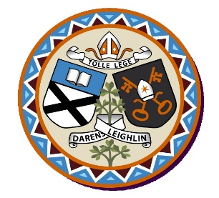
Saint Oliver Plunkett National School, Killina
Annual Admission Notice
in respect of admissions to the 2021/2022 school year

Admission Policy and Application Form
A copy of the school’s Admission Policy and the Application Form for Admission for the 2021/22 school year is available as follows: –
To download at: www.killinans.com
On request: By emailing office@killinans.com or by writing to the school at the address Killina, Carbury, Co. Kildare, W91 XC62

Admissions to the 2021/22 school year

Application and Decision Dates for admission to 2021/22
The following are the dates applicable for admission to Junior Infants

The school will commence accepting applications for admission on | January 14th 2021
The school shall cease accepting applications for admission on | February 4th 2021
The date by which applicants will be notified of the decision on their application is | February 18th 2021
The period within which applicants must confirm acceptance of an offer of admission is | February 25th 2021

Note: the school will consider and issue decisions on late applications in accordance with the school’s Admission Policy.

*Failure to accept an offer within the prescribed period above may result in the offer being withdrawn

Number of Places being made Available in 2021/22

The number of places being made available in junior infants | 15

