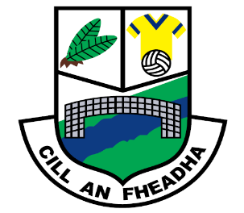
St. Oliver Plunkett National School
Killina, Carbury, Co. Kildare
Tel: 046 955 3522
Email: killinans@eircom.net
Website: www.killinans.com

Principal: Dominic Tyrrell Deputy Principal: Teresa Noonan
Dear Parents,

Please find below a list of work for the children to complete over the next two weeks. We ask that parents encourage the children to do schoolwork for a given time every day and to encourage the children to complete this work to the best of their ability.

Third and Fourth Class

Let’s Go! | Neilly and the Fir Tree  Read pgs. 54 – 61  - Answer questions pgs. 62 and 63 – B, C, D, E, F and G.  The Giant Redwood and Amazing Trees  Read pgs. 64 – 67  - Answer questions pgs. 68 and 69 – B, C, D and E.
Word Wise | Television Programmes: Read pg. 48 and answer questions pg. 49 – A, B and C.  Singular and Plural: pg. 50 – A, B and C.  Tricky Words 2: pg. 51 – A and B.  Read page 52 and do questions page53 – A, B and C.
Spell Well | - Units 18 and 19
Fuaimeanna agus Focail | - Units 18 and 19
Handwriting | - Small Handwriting Book – 2 pages.
Maths Book | - Sheets
Small World History | Unit 4: The Celts:  Read the chapter and answer questions page 23 – A, B and C.  Unit 5: The Romans:  Read the chapter and answer questions page 29 – A, B, C and D.
Small World Geography and Science | Unit 4: People at work:  Read the chapter and answer questions Pages 24 and 27.  Irish Trees:  Read pages 28 and 29 - write a fact file on your three favourite tress.

We thank you all for your support in this very uncertain time and we hope that we can get back to normality in the near future. Keep safe and healthy!
Kindest regards,

Ms. Dalton

