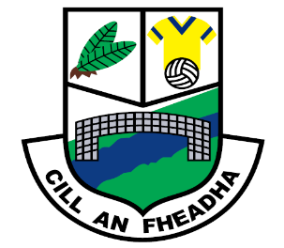
St. Oliver Plunkett National School
Killina, Carbury, Co. Kildare
Tel: 046 955 3522
Email: office@killinans.com
Website: www.killinans.com

Principal: Dominic Tyrrell Deputy Principal: Teresa Noonan
Dear Parents,

Please find below a list of work for the children to complete over the next two weeks. We ask that parents encourage the children to do schoolwork for a given time every day and to encourage the children to complete this work to the best of their ability.

Second Class

English Reading | Feena’s Second Book of Facts  Read the following chapters and talk about the content:  - Pages 10-11 (Food and Farming)  Pages 12-13 (Jobs and Work)  - Pages 14-15 (Sports and Games)  - Pages 16-17 (Machines in the Home)  - Go back over reader ‘A Surprise for Feena’ or ‘GGs New Job’
Word Work | - Revise the Dolch List of 220 words every day please  - Read back over all word lists in folder
Word Wise | - Chapter 14 (pages 54 to 59)  - Chapter 15 (pages 60-63)
Spelling | - Units 22 and 23
Handwriting | - Small Handwriting book up to page 27
Maths Book | - Place Value (pages 99 – 103)  - Patterns (page 124 – 129)  - Tables sheets – Subtraction 10, 11 and 12  - Go back over all tables (addition 1-10) and subtraction (1-9)  - Practice adding and subtraction of tens and units
Small World | - Family Photograph (pages 80 -81)  - Compost (page 53)
Religion | - Grow in Love pages 35, 36, 37, 38, 39, 40 and 41  - Communion Prayers (we have not done these yet but I’m worried that we will not have enough time to do them when we get back so that they are ready for the Communion).
We thank you all for your support in this very uncertain time and we hope that we can get back to normality in the near future. Keep safe and healthy!
Kindest regards,

Dominic Tyrrell

