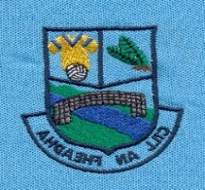
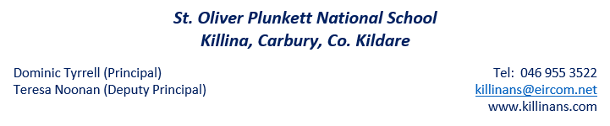
Plunkett’s Post

Welcome back to everyone for our next school term and a very Happy New Year to all of our families. We wish each member of our school community the best of health and happiness for 2019. We hope that you had an enjoyable Christmas break and that you enjoyed lots of family time. We are delighted to see the boys and girls back for our new term and we look forward to the many exciting things that we have planned for this term. This newsletter gives a brief overview of some events and activities that the school has to look forward to.
Winter bugs and flu symptoms
A reminder that if your child is unwell, please keep them at home until they are feeling better. We want to minimise the transfer of germs/bugs within our classrooms. It is also important to remember that if your child is well enough to attend school then they are also well enough to partake in yard and other activities. For more information on keeping well this season, please check out www.undertheweather.ie. Please remember to send a note into school if your child has been absent.
Bag Pack Volunteers
Many thanks to the parents who have offered their support to volunteer at our Bag Pack in Dunnes Stores on Friday and Saturday (25th/26th January). We really need your support and hope that you will give the school two hours of your time to support this very worthwhile fundraiser.

Peace Proms
Our 3rd to 6th class children are busy preparing for the Peace Proms concert. It will be taking place on February 2nd in the RDS. We are very excited to be taking part in this huge event and we look forward to showcasing the children’s hard work whilst on stage. There are still some tickets available if parents wish to purchase them. Please visit www.peaceproms.com. More information to follow.
Hurling
All boys and girls will have hurling training this Friday (18th January) during school. We ask that the boys and girls wear their tracksuits into school. This is an introduction session for all classes to whet the children’s appetite.
3rd to 6th will then have a block of coaching sessions in January/February whilst Junior Infants to 2nd class will have their block of hurling lessons in May/June.
Voluntary Contributions
Many thanks to our families who have generously submitted their Voluntary Contributions. Please contribute whatever you can when you receive the small brown envelope and send it back into the school. If you have any questions about the voluntary contributions, please come to speak with Mr. Tyrrell.

Absences
If your child is absent, please send in a written note explaining the absence and including the date. When we report absences to the Welfare Board we are required to write ‘unexplained’ if no explanation note has been given. It is also important for me to remind parents of our statutory obligation to make a formal report to the Welfare Board for any child who misses 20 days or more in a school year, hence the importance of sending a note into the school.
Roll Call
Roll is called each morning at 10am. Children who are not present for roll are marked absent unless the teacher has received prior notification that the child is attending a dental or doctor’s appointment etc. and intends coming in later to school. Once marked absent the roll count cannot be changed. Please send in written notification the day previous. We also ask that parents try to minimise collecting students before the end of the school day as it can be quite disruptive to the class and student when they are taken home early.
Text A Parent
As you are aware we use the ‘Text a Parent’ app to keep you informed of school events. If you have a smart phone you can download the Text A Parent app. It is cheaper for the school to send a text if you have the app. A link to the app will be posted on our website. Please also remember to update the school if you change your mobile number.
6th Class Confirmation Retreat
The children will be attending a retreat in Curryhills in Prosperous on the 7th February 2019. More information to follow.

Ceremony of Light
Saturday 16th February at 7.30pm, Church of the Holy Trinity, Derrinturn. The children will need to bring their Baptismal Candle with them on the night. If you have lost or misplaced your Baptismal Candle, you can buy a new white candle in Bergin’s XL.
Confirmation Ceremony
Killina, Kilshanroe and Ticknevin will have their Confirmation Ceremony at 11am in the Church of the Holy Trinity, Derrinturn on Wednesday 27th February at 11am. Bishop Denis Nulty will celebrate mass, with Fr. Fitzpatrick and Fr. Murphy concelebrating. We wish all of the candidates every blessing. We hope you all have a lovely day.
Communion
Date: Saturday 18th May 2018.
Holy Trinity Church, Derrinturn.
Active Schools
Children have completed a Poster Competition for the Active Flag. Winners will be announced at the next Assembly. The Committee are busy organising Spring Activities and they will be launching our Twitter account in the coming weeks.
Clothes Collection
We will have a clothes collection at the end of January/early February. Please begin to gather up any items of clothing, shoes, belts, handbags etc. No duvets, cushions or pillows accepted.

Green Schools
Battery Collection
Collection boxes have been distributed by the Green School Committee to all families. If you have waste batteries, especially following Christmas, please send them in to our Battery Collection Area.
Biodiversity Awareness Survey
The committee are currently working on a biodiversity awareness survey as we near the end of our theme of biodiversity. We will compare results from Autumn 2017, when we embarked on our Biodiversity Theme. We look forward to seeing how much the pupils have learned over the 2 years.

