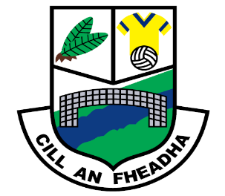
St. Oliver Plunkett National School
Killina, Carbury, Co. Kildare
Tel: 046 955 3522
Email: office@killinans.com
Website: www.killinans.com

Principal: Dominic Tyrrell Deputy Principal: Teresa Noonan
Dear Parents,

Please find below a list of work for the children to complete over the next two weeks. We ask that parents encourage the children to do schoolwork for a given time every day and to encourage the children to complete this work to the best of their ability.

First Class

English Reading | Feena’s First Book of Facts  Read the following chapters and talk about the content:  - Pages 10-11 (Muscles  Pages 12-13 (How we Live)  - Pages 14-15 (Clothes)  - Pages 16-17 (Staying Healthy)  - Go back over reader ‘Dance Shoes for GG’
Word Work | - Revise the Dolch List of 220 words every day please  - Read back over all word lists in folder
Word Wise | - Chapter 14 (pages 54 to 57)  - Chapter 15 (pages 58 to 61)
Spelling | - Units 22 and 23
Handwriting | - Small Handwriting book up to page 27
Maths | - Subtraction (pages 106-110)  - Counting (pages 125 – 130)  - Tables sheets – Subtraction 10, 11 and 12  - Go back over all tables (addition 1-10) and subtraction (1-9)
Small World | - Family Photograph (pages 80 -81)  - Compost (page 53)
Religion | - Grow in Love pages 35, 36, 37, 38, 39, 40 and 41
We thank you all for your support in this very uncertain time and we hope that we can get back to normality in the near future. Keep safe and healthy!

Kindest regards,
Dominic Tyrrell

