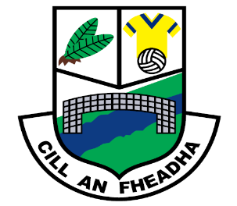
St. Oliver Plunkett National School
Killina, Carbury, Co. Kildare
Tel: 046 955 3522
Email: office@killinans.com
Website: www.killinans.com

Principal: Dominic Tyrrell Deputy Principal: Teresa Noonan
Dear Parents,
Please find below a list of work for the children to complete over the next two weeks. We ask that parents encourage the children to do schoolwork for a given time every day and to encourage the children to complete this work to the best of their ability.
5th and 6th Class
English | Writing  Above the Clouds Portfolio Book  - The 1000 Year Old Boy pages 64-65  - Parvana`s Journey pgs 64-69  - Invasion page 133, 138,139  Handwriting Book  1 page each day
Maths | One side of photocopied worksheet each day- most sums will need to be calculated in Maths copies and labelled (page number and title)  One page of Brain Teasers each day
SESE | History  Small World History  -Unit 9 : Ireland in the Sixteenth and Seventeenth Centuries  Read text and answer questions in History copy (page 44, page 47 A, B, C and D (choice of number 2 0r 3)  Geography  Small World Geography and Science  Unit 12: Continue reading pgs.67-71  Answer questions in Geography copy ,page 69 no.1-7, page 71 no.1-5  Complete “European Country Research “ sheet.  Science  Small World Geography and Science  Read Unit 10: Our Environment  Answer questions in Science copy page 57 no.1-7,page 59 no.1-5
We thank you all for your support in this very uncertain time and we hope that we can get back to normality in the near future. Keep safe and healthy!
Kindest regards,
Mrs. Noonan

